Name: _____________________________________________________________ Period: ___________
How Plates Move
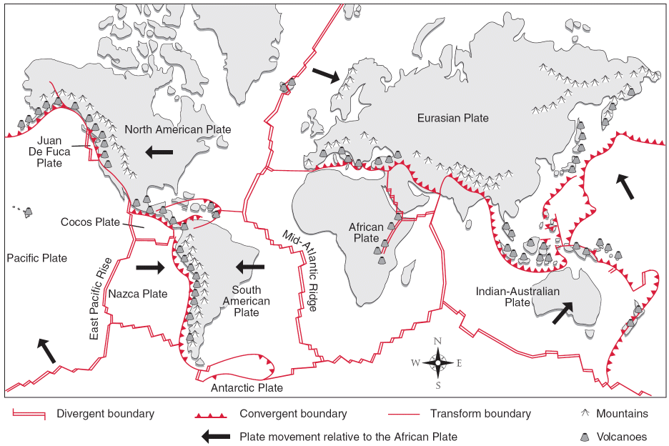
Directions: Refer to the diagram above to answer the following questions.
- What are the three types of plate boundaries?

- Describe the type of movement that occurs at each type of plate boundary.

- What will likely occur at a plate boundary where oceanic crust collides with continental crust?

- In what direction is the part of the plate carrying Washington State moving?

- In what direction is the Pacific plate moving?

- As the North American plate and Juan de Fuca plate move, what type of plate boundary will form between them?

- As the Juan de Fuca plate and the Pacific plate move, what type of plate boundary will form between them?

- What features could occur where the Juan de Fuca plate is colliding with the North American plate?

- Today, the Mediterranean Sea lies between Europe and Africa. But the African plate is moving toward the Eurasian plate at a rate of a few centimeters per year. Predict how this area will change in 100 million years. In your answer, first explain how the Mediterranean Sea will change. Then explain what will happen on land.

- Find three examples of colliding plate boundaries. What kinds of activities will occur here?

- Find two places where plates are sliding by each other. What do you predict will happen there?

- When plates collide, the continental crust thickens and buckles as the plates are compressed. Locate the Himalayas and the Rocky Mountains. Could they have been formed this way?

